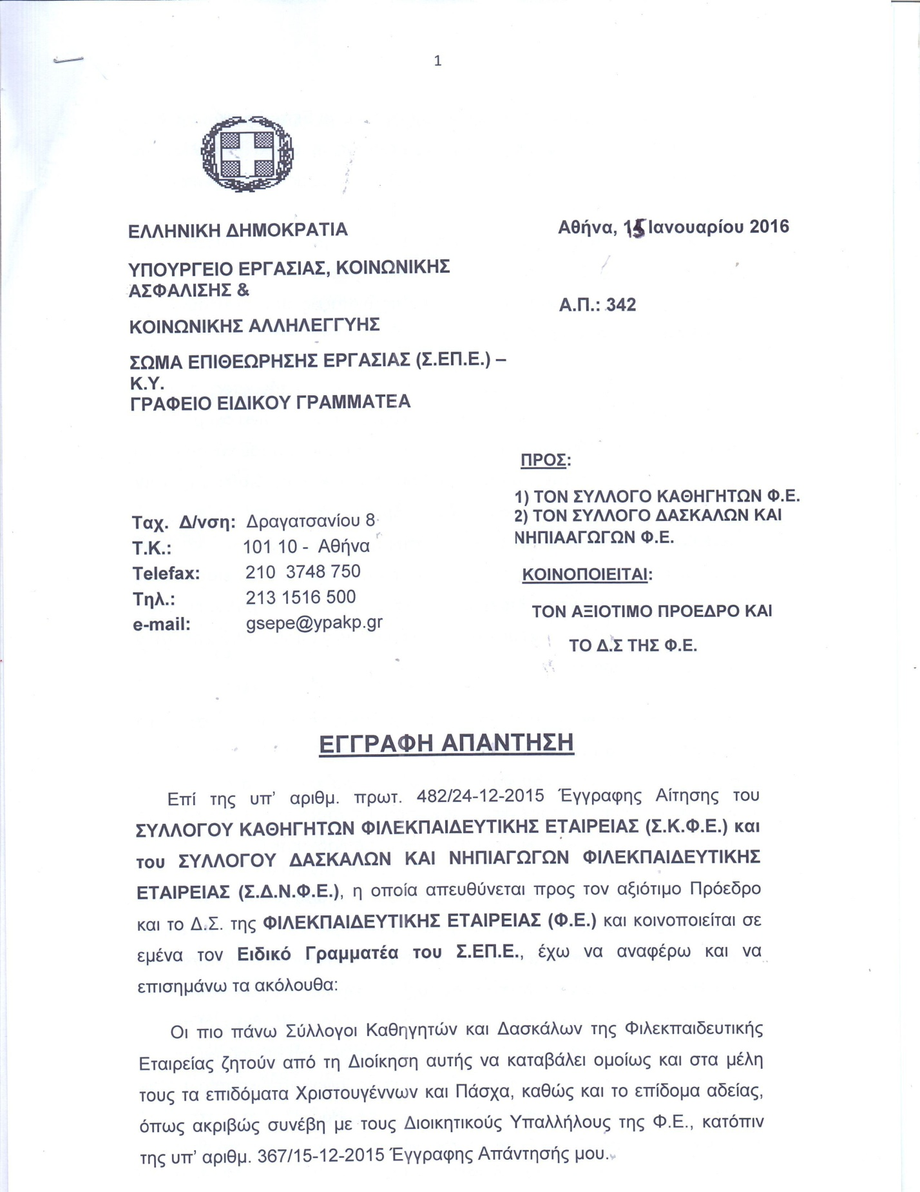

C:\Documents and Settings\anna\Desktop\Untitled000.tif

C:\Documents and Settings\anna\Desktop\3.tif

C:\Documents and Settings\anna\Desktop\4.tif