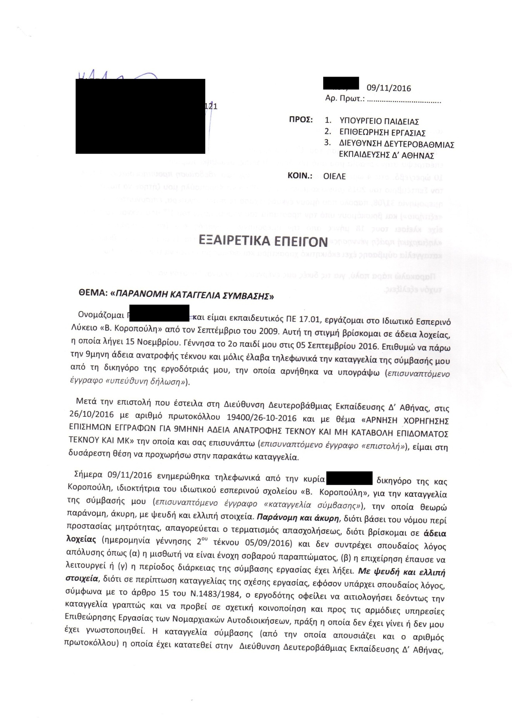

C:\Documents and Settings\anna\Desktop\2.tif